

Welcome to the Bone and Joint Infection Registry User Manual
We hope this will help get you started understanding and using the registry.

The Bone and Joint Infection Registry (BAJIR) is a national project that aims to improve our understanding of infections in both normal bones and joints and those that have previously undergone operations, including joint replacements.

These infections are rare but can be difficult to treat and often require prompt and efficient treatment by a specialist team of surgeons, microbiologists and radiologists experienced in managing these problems in order to optimise the outcome. The aim of the registry is to improve care for patients who suffer from these conditions by recording how treatment is delivered across the UK.

Which patients are suitable for the Bone and Joint Infection Registry?

• Periprosthetic infections
• Native joint infections
• Native long bone infections
How does the registry work?

Patients who present with a bone or joint infection are added to the registry by the local treating team. Initial information regarding the patient’s demographics, site of infection and comorbidities is recorded. Subsequently data regarding diagnostic test results, causative organism, antibiotic and surgical treatments is added. Baseline patient reported outcome measures are collected by the treating team. Subsequently patients are followed up by the BAJIR registry team, to obtain their consent and collect patient reported outcome measures are at 6m, 12m and then at yearly intervals. Trusts will have access to their own data via a live dashboard and the ability to download their own data.

Joining BAJIR

If you would like to join the Bone and Joint Infection Registry BAJIR then please contact us via email at nhc-tr.bajir@nhs.net

There will be some work required to get your trust through the legal agreements to allow data sharing between you and the registry, but we will help you through this
Contents Page How to register & access BAJIR
How to register & access BAJIR
Main Menu
Edit / Enter Data
New Patient
Triage Outcome
Add / Edit Co-morbidity
Add / Edit Infected Site
Site
Surgery
Aspirate
Histology
Microbiology
Complications
Blood tests
Medical Management
REGISTRY DIAGNOSIS
MDT
Follow-Up and PROMs
My Patients
Timeline
For additional support

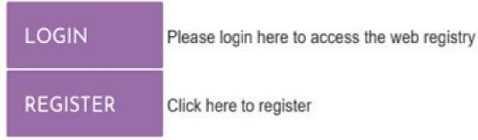
You are required to register one time only in order to receive your login details.
Once these details have been received and we have confirmed that your organisation has a signed data sharing agreement in place, you will receive confirmation that you are now registered to use BAJIR.
If you do not receive your login details within 5 working days then please contact:

DENDRITE Clinical Systems Ltd
Telephone: 01491 411 288
Email: national-support@e-dendrite.com



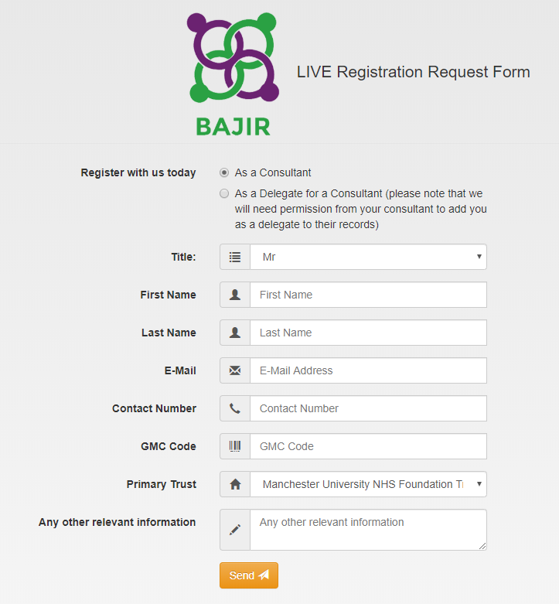 | 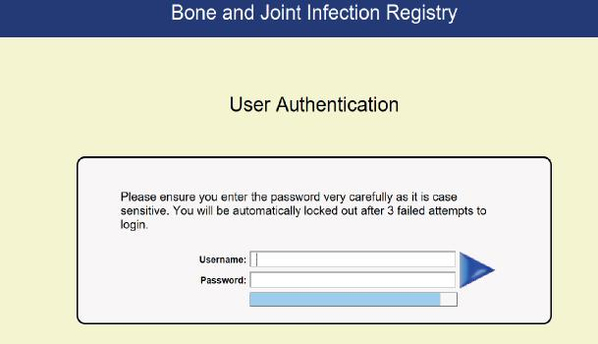
 | Please note
How to register & access BAJIR

If you do not enter your user name and password correctly within three attempts, your account will be temporarily locked. If this happens please email Registrations@e-dendrite.com who will reset your account for you
When completing the registration process, please consider the following:

Before we create your user account we will need to confirm that your organisation has a signed data sharing agreement in place and that the registry lead for your organisation has authorised your account.

Delegated User: Please note that we will require confirmation that you have the necessary authorisation from the consultant for whom you wish to delegate

Main Menu
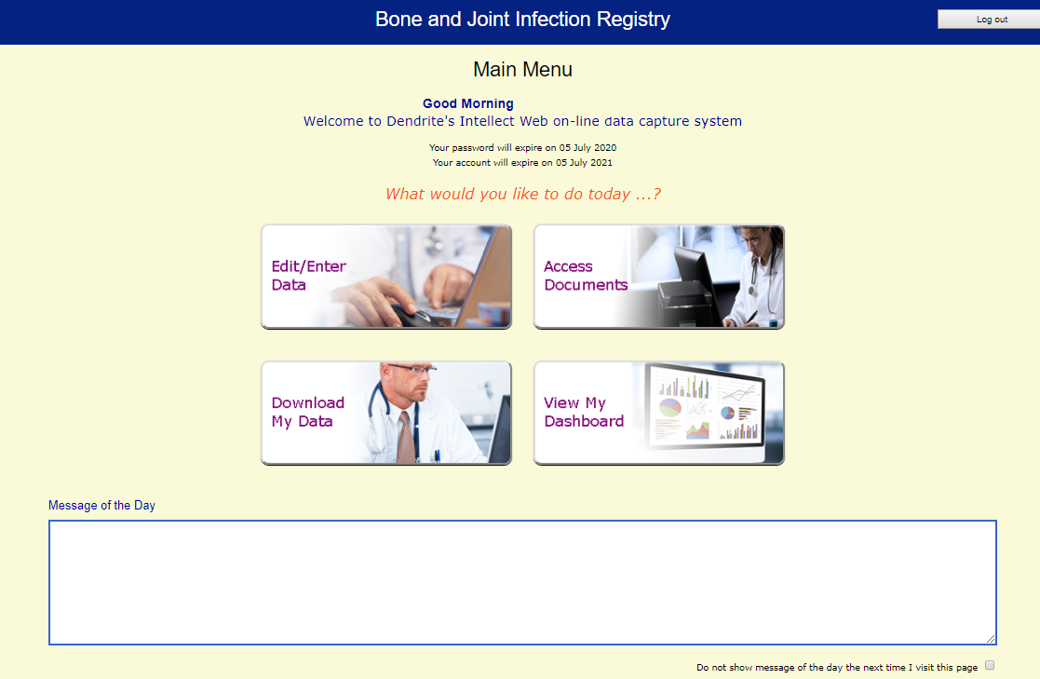

Details of your login are shown here. If you are approaching the expiry date, please contact the Registrations Team at Registrations@e-dendrite.com

Activating the message box will mean that you receive regular notifications in relation to the registry.

These will appear on the main menu and will be available when you login


This tab contains links to key
documents in relation to the
registry. These documents
include PAS Code Descriptors,
patient information leaflets, site
set-up documents
This tab is where case
information is collected and
recorded.
Case data is accessible to those
users who have entered data into the registry. This tab allows the user to view and / or export
their information
This tab allows the user to view
the number of cases in the
Registry that your organisation
currently has and the total
number in the Registry. This
area continues to be under
development
Once case information has been added to the registry, users can search for specific cases of interest by using any of the search fields seen here; forename, surname, NHS Number, Hospital Number, Date of Birth or Date of Referral to Service
This is where the cases for the registry are first created. To add a new case, click on Add New Patient
Users can return to the Main Menu at any time. Data entered into the record will automatically be saved
Users can log out of the registry at any time. Data entered into the record will automatically be saved


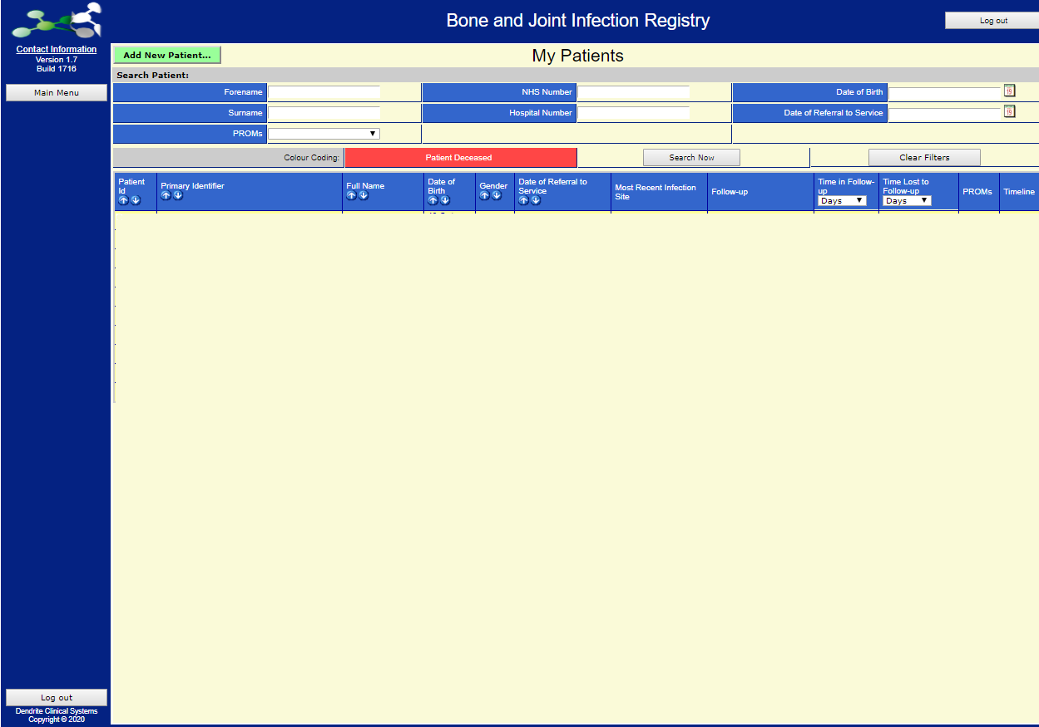

Edit / Enter Data
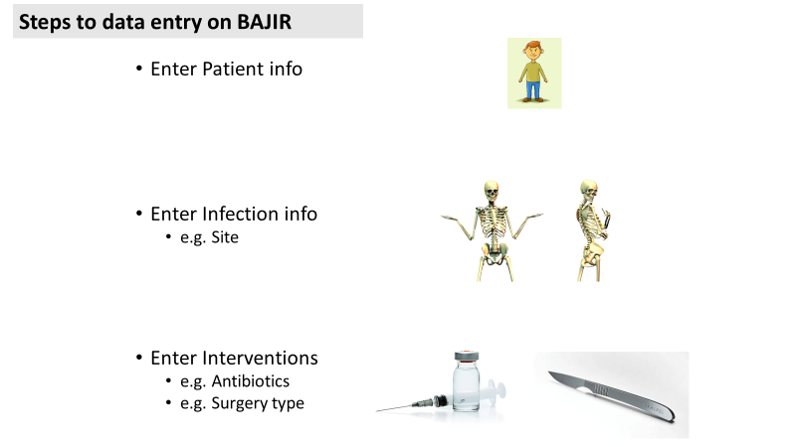

Edit / Enter Data – New Patient

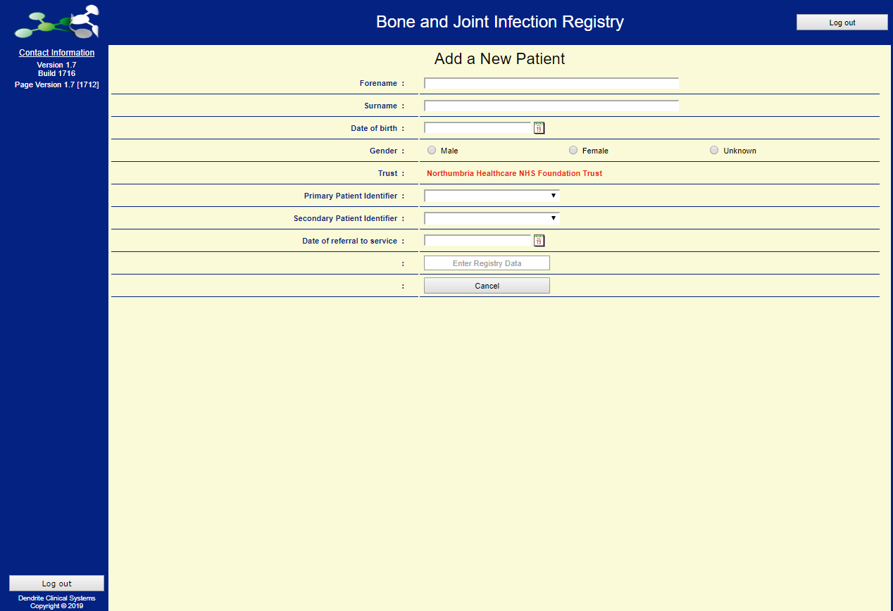
Trust: this will be pre-populated based on the trust associated with your account
Once the Add New Patient button has been clicked, this screen is available and
enables the basic information to be added.
This is the start of the case building process for each patient record

Primary Patient Identifier: this must be NHS Number (England and Wales), or CHI Number (Scotland)
Secondary Patient Identifier can be Armed Forces Number, Private Patient Hospital Number, Foreign Patient Hospital Number, Local Hospital Number

Edit / Enter Data – New Patient

Patient demographics are added here.
These cannot subsequently be edited so must be completed in full at the time of registering a new patient.

NB: Error messages can occur if an incorrect format is used for NHS number, or if the same NHS number has already been registered previously.
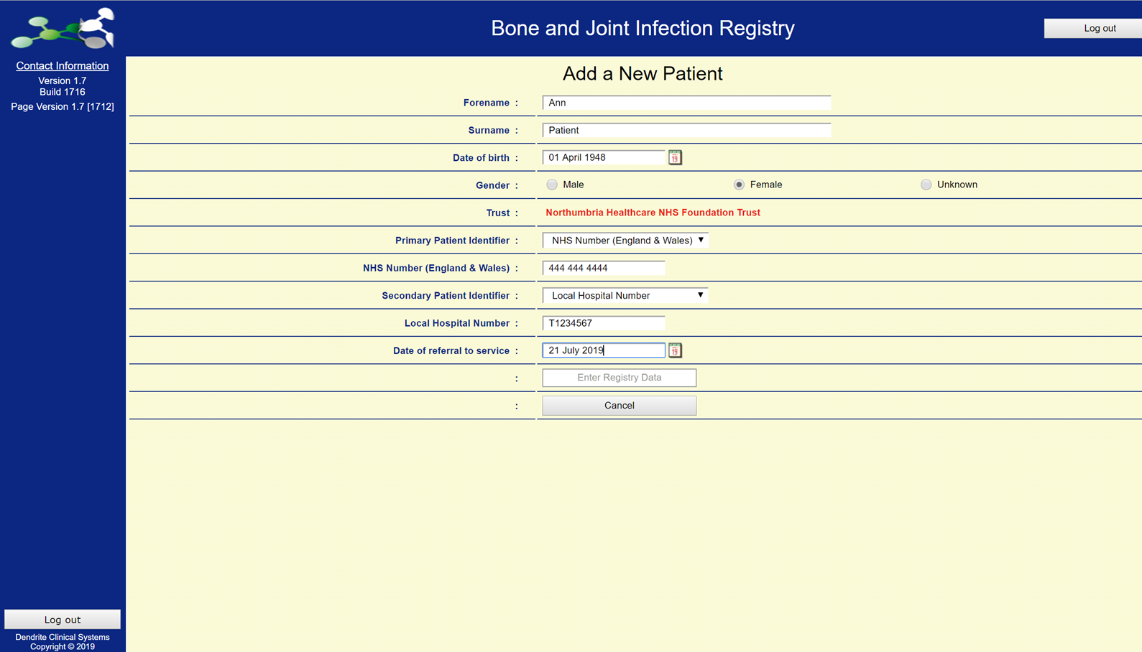

Once the Enter Registry Data button has been clicked, the next page opens for additional patient-level information to be added.

Edit / Enter Data – New Patient

Here, additional information is added to the patient’s record, including details of the source of referral:

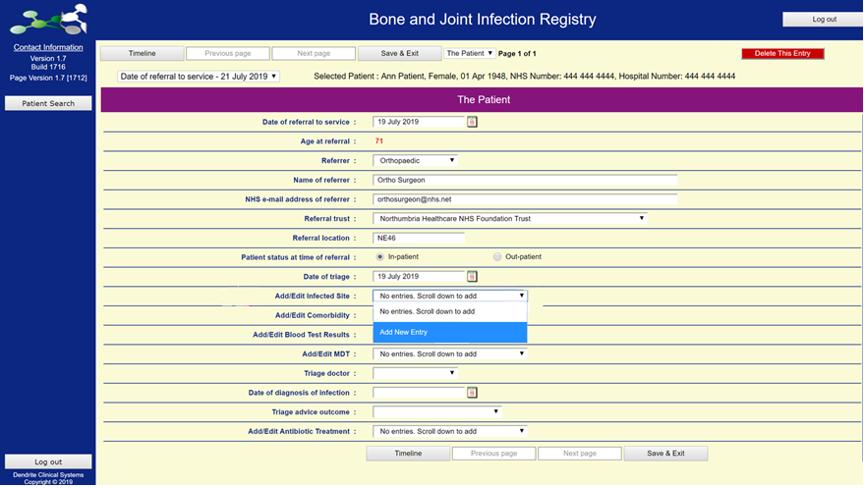
Referral location requires the first part of the patient’s postcode to be entered at this time.

After date of triage, there are four drop-down boxes which, if activated / completed, will invite the user to add supplementary and important information relating to each of the options selected.

The next few pages will explore these in detail.
Triage Outcome

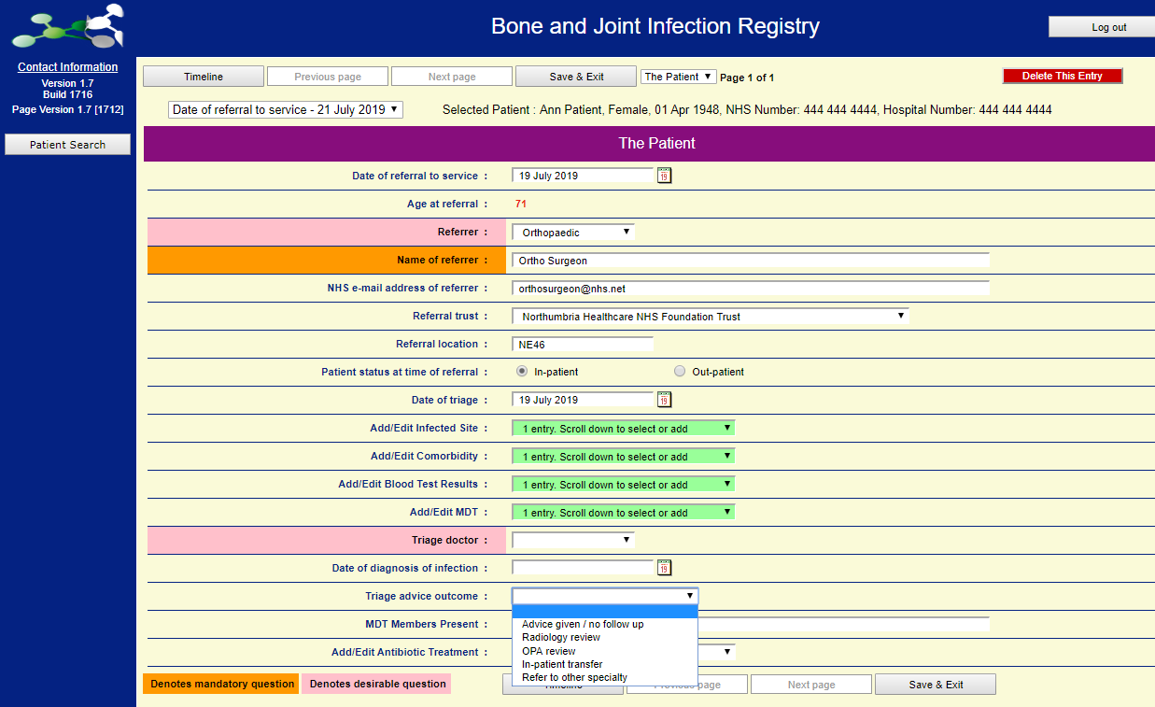
Depending on the option selected, different follow-on boxes appear for completion

Add/Edit Comorbidity Page 1 of 2

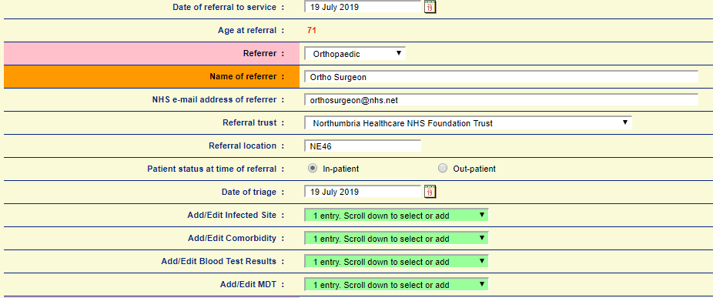

The user should add as much information as possible to the record so that there is a detailed history regarding the patient’s clinical pathway.

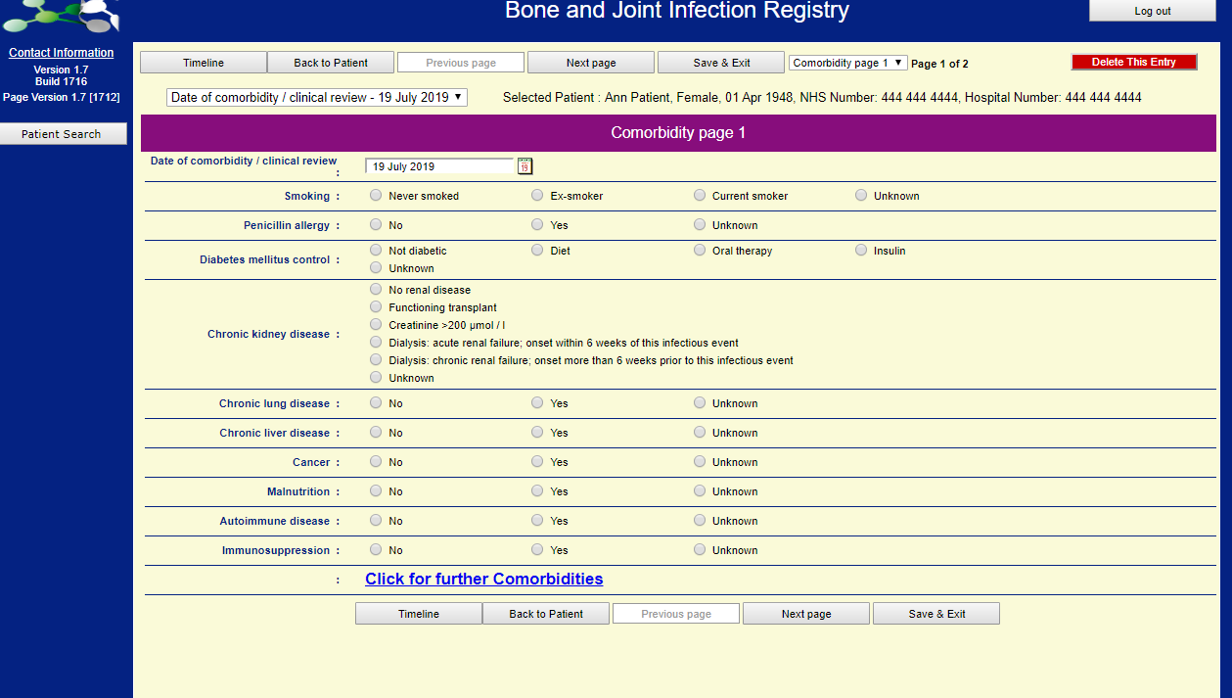

Click Next Page not
Save & Exit which returns you to the Main Menu screen.
Add/Edit Comorbidity Page 2 of 2

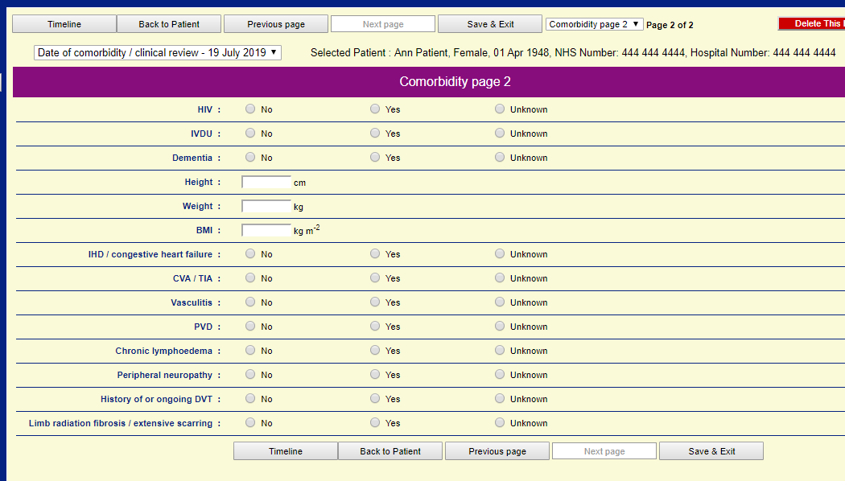
Click on

Save & Exit
Add / Edit Infected Site 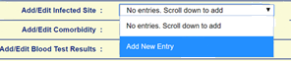

Drop down boxes are available for ease of use where possible.

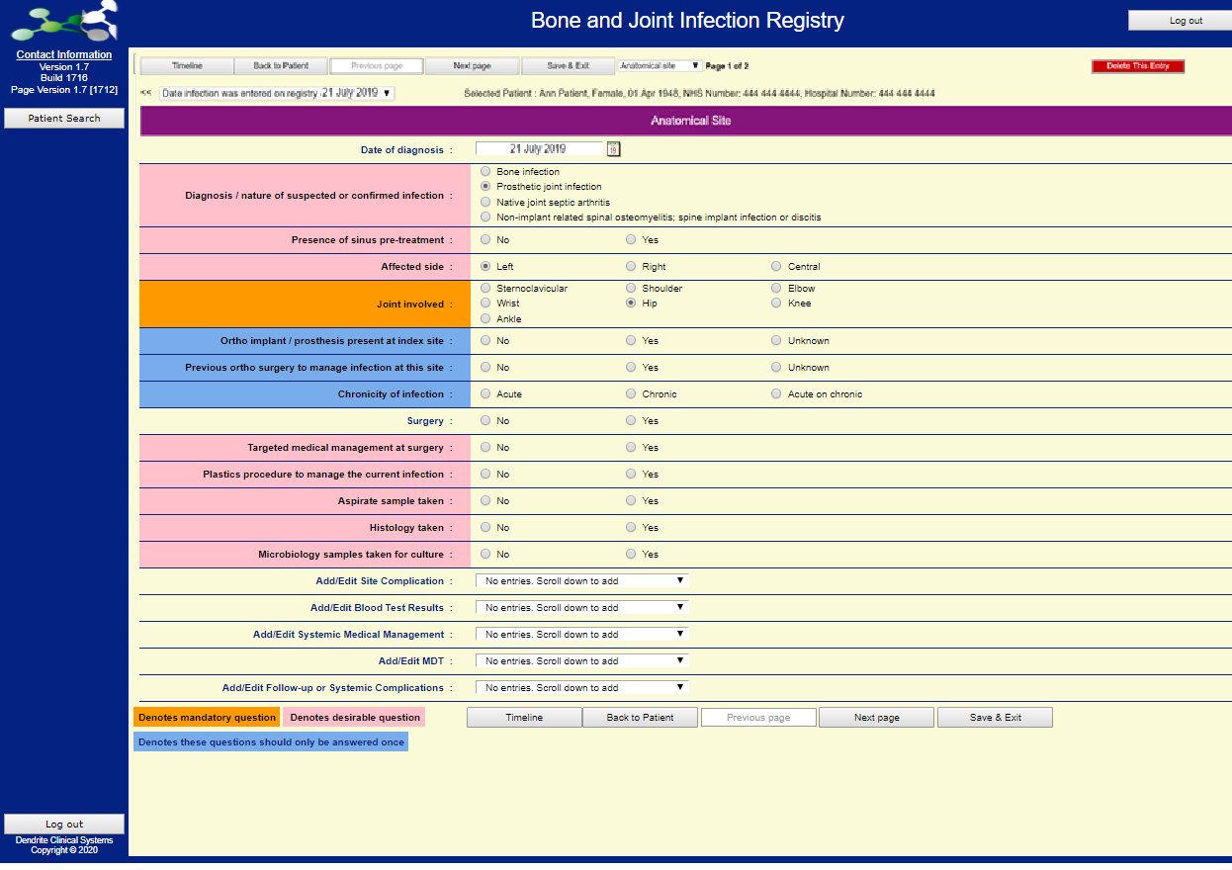
It is important to include as much information as possible.
There are system-level messages to act as a reminder to add information either as the case is entered
or as it becomes available

Add / Edit Infected Site - Surgery

For this entry into the registry, the clinical decision is that surgery will be required.
This option allows the user to add supplementary data to the patient’s record as shown below:

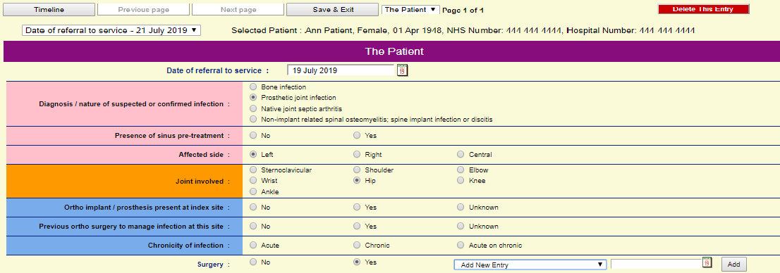

If surgery is selected as a clinical option for the patient, below is the range of options available for selection in the registry:
When adding each section of the Infected Site
ensure you click
“Back to Site”
to add the next section.

“Save & Exit”
will take you back to the home screen
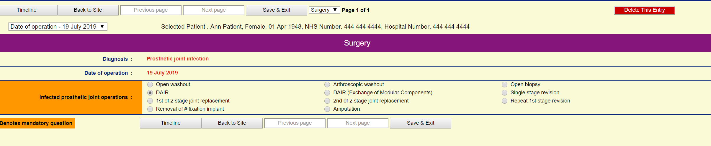

Add / Edit Infected Site - Aspirate

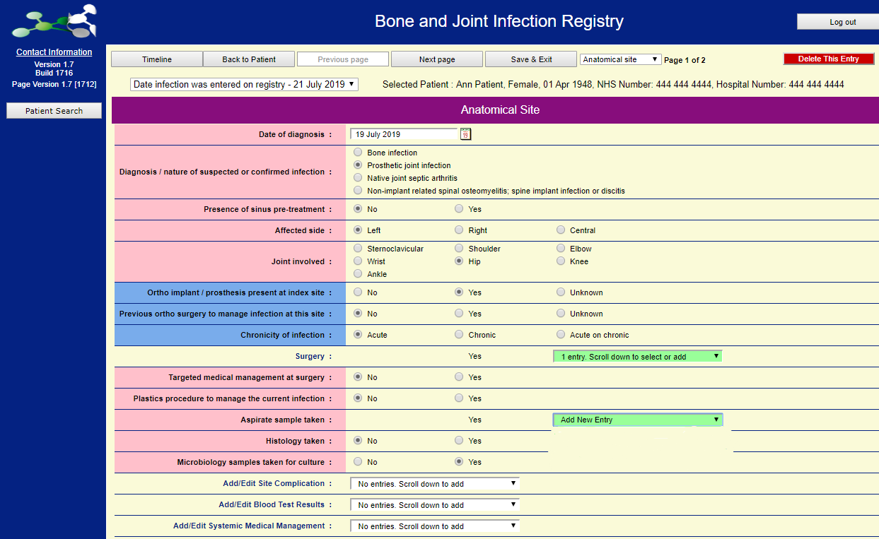

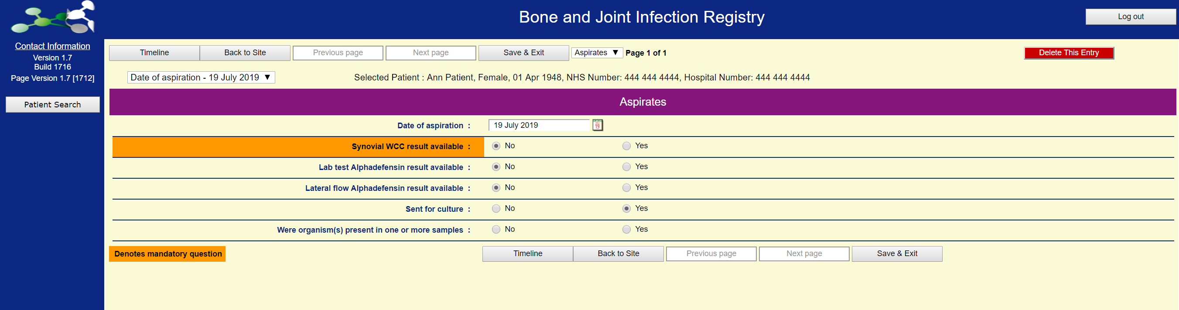

If test results are not available at the time the patient details are added to the registry
they can still be added later once the results are known.

Add / Edit Infected Site - Histology
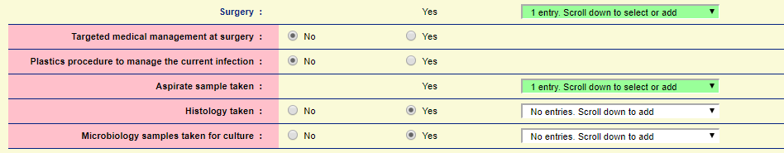

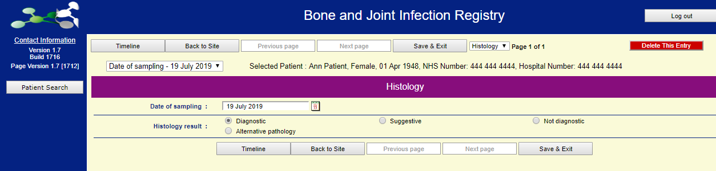

Add / Edit Infected Site - Microbiology

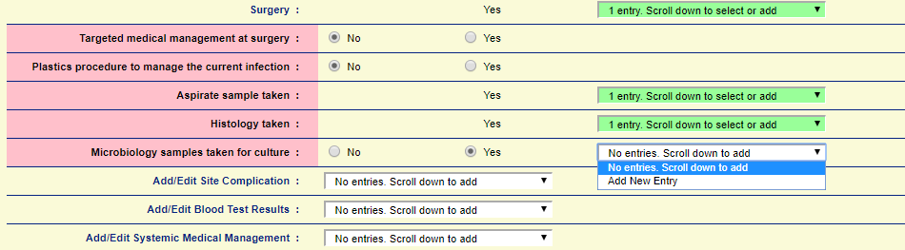

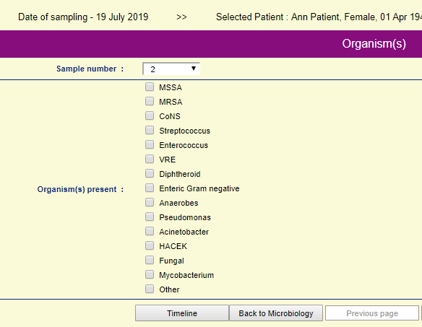

Each organism present can be recorded individually for clarity

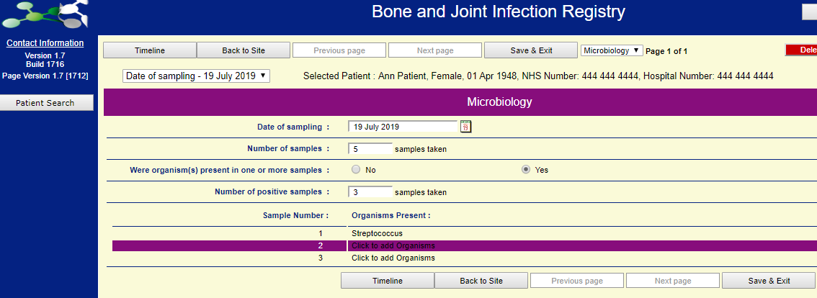
Add / Edit Infected Site – Complications
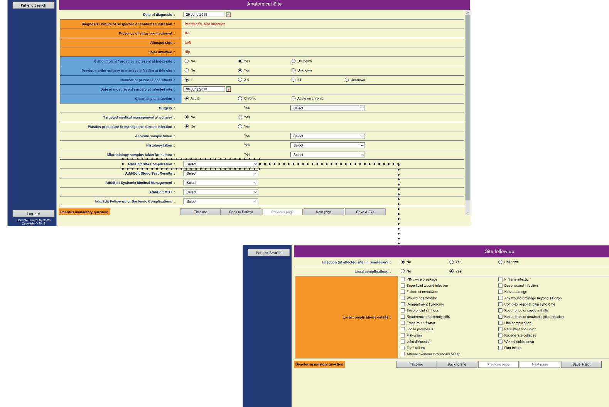
In the event that an infection fails to go into remission post-treatment, additional information regarding the ongoing complications can also be added to the Registry

Add/Edit Infected Site – Blood Tests

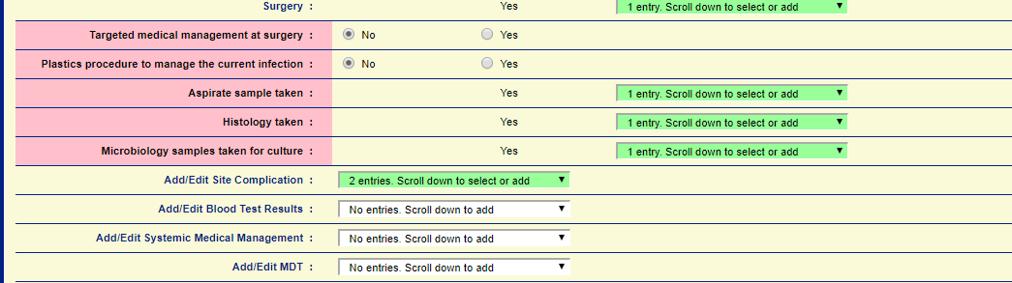
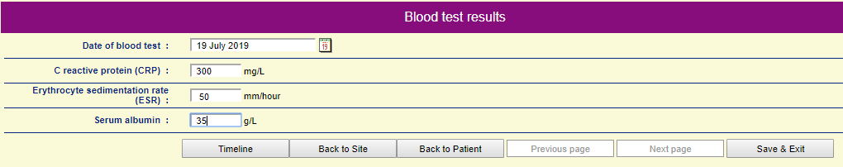

Please ensure baseline blood tests are added to the registry.
Further sets of blood tests can be added if desired.

Add/Edit Infected Site – Medical Management
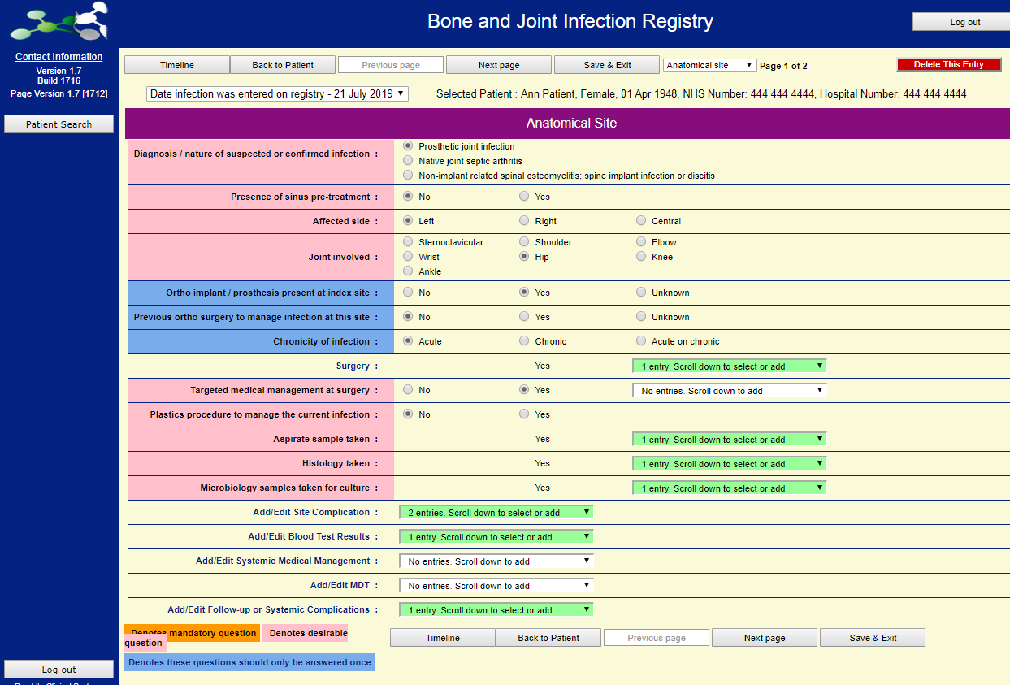

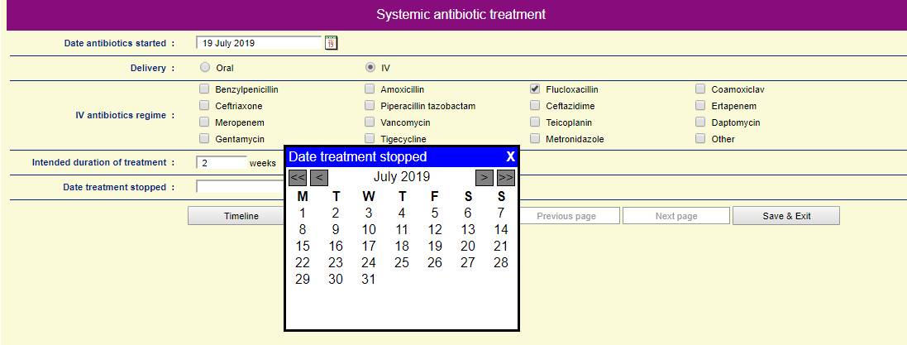
As with blood results, it is also possible to add more than one course of medical treatment undergone by the patient.

Taking the time to add all courses will add to the richness of any case review

Add/Edit Infected Site – Registry Diagnosis

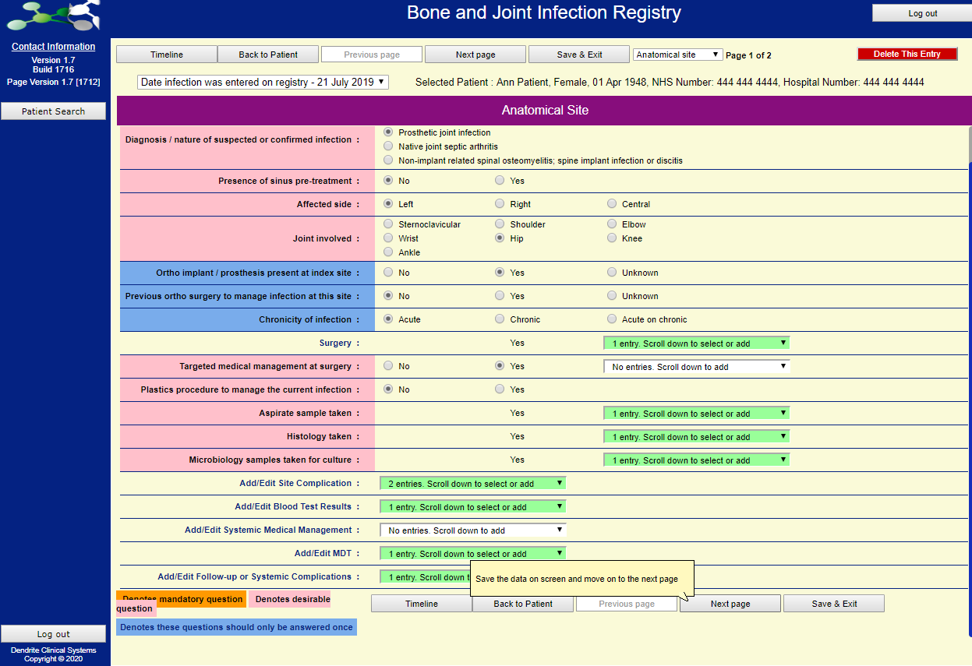
All of the (previously covered) sections under “Infected site” can be entered at different times as information becomes available, and for each clicking “Save & Exit” returns the user to the main menu.

Once ready to enter a confirmed diagnosis of infection
(or confirmation that there is no infection)
Click on Next Page
not
Save & Exit….
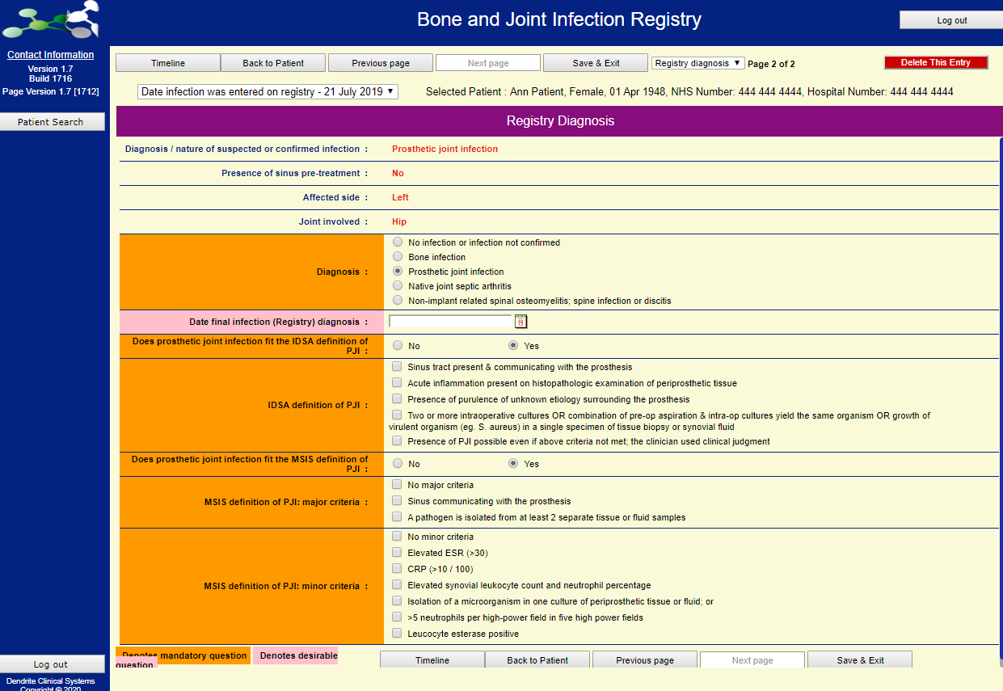
Click on

Save & Exit

A confirmed diagnosis of infection is required in order to trigger patient consent and follow-up PROMs
at 6-months, 1-year and annually thereafter.
Without a confirmed diagnosis, the patient details will be removed from the registry after 18-months.
Add/Edit Infected Site – MDT
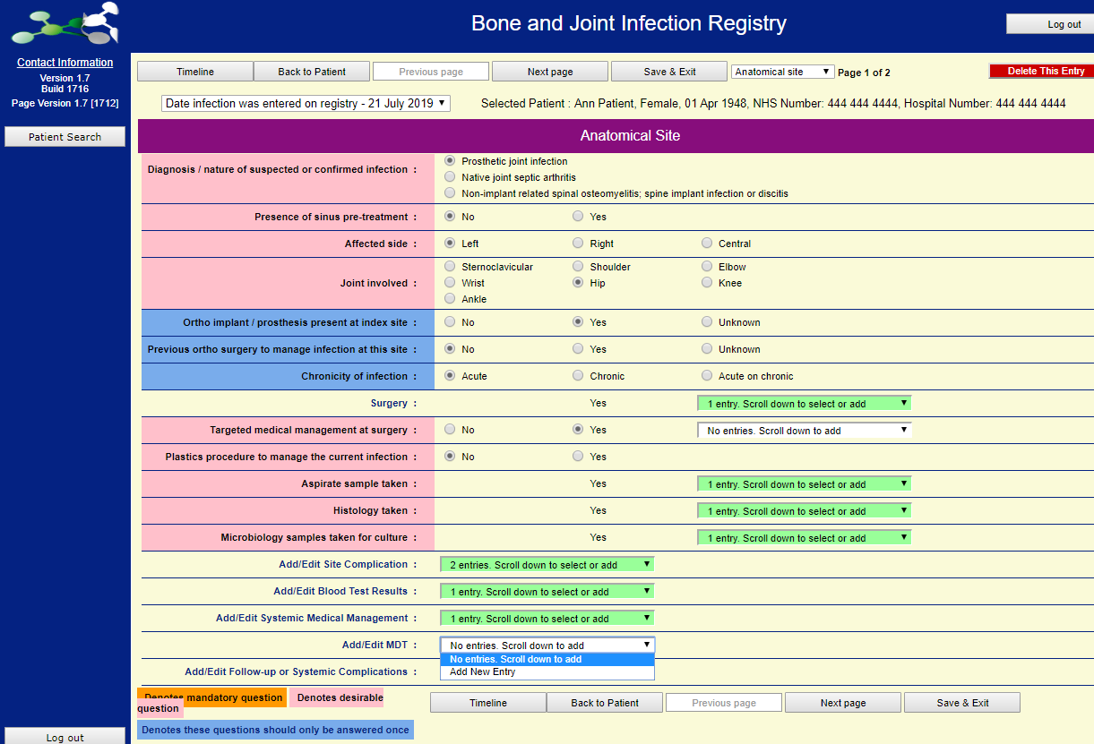

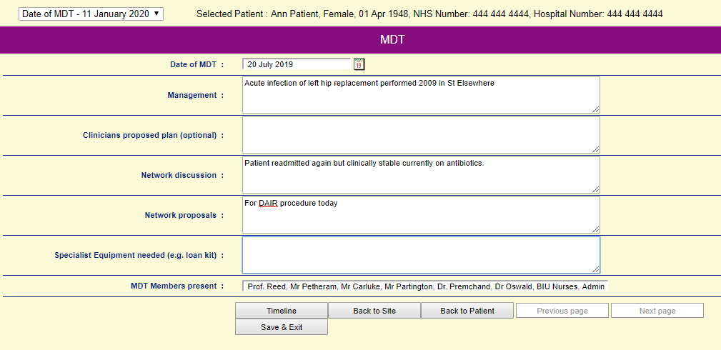
Text can be copied & pasted into these boxes from other documents.
Click on

Save & Exit
Patient Follow Up - Systemic Complications
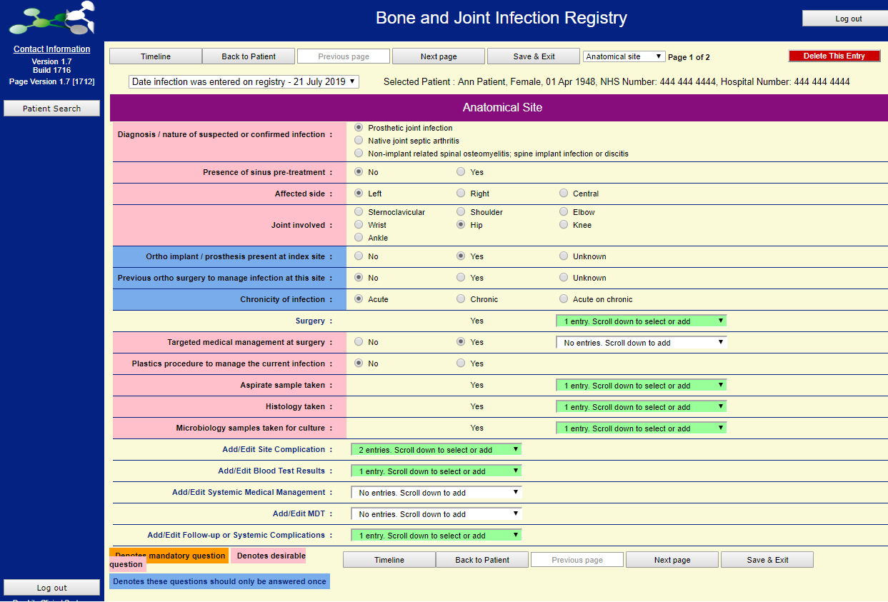

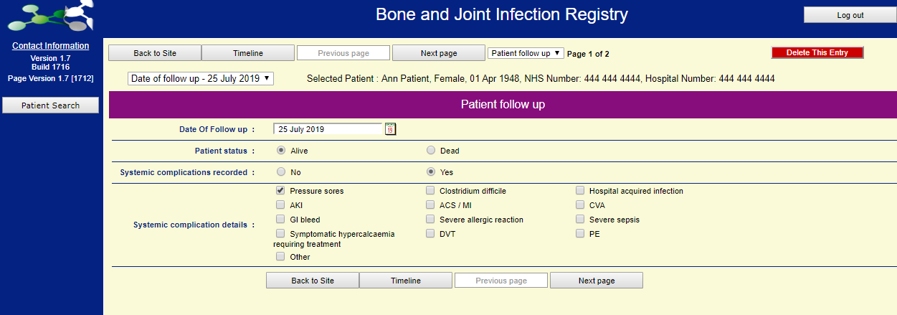
The patient can be followed up until the end of the case.
After entering systemic complications, the next screen records baseline PROMs.
If no systemic complications, entering “no” will lead to the next screen where PROMs can be entered.
Follow-Up and PROMs

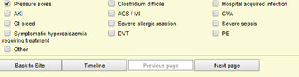

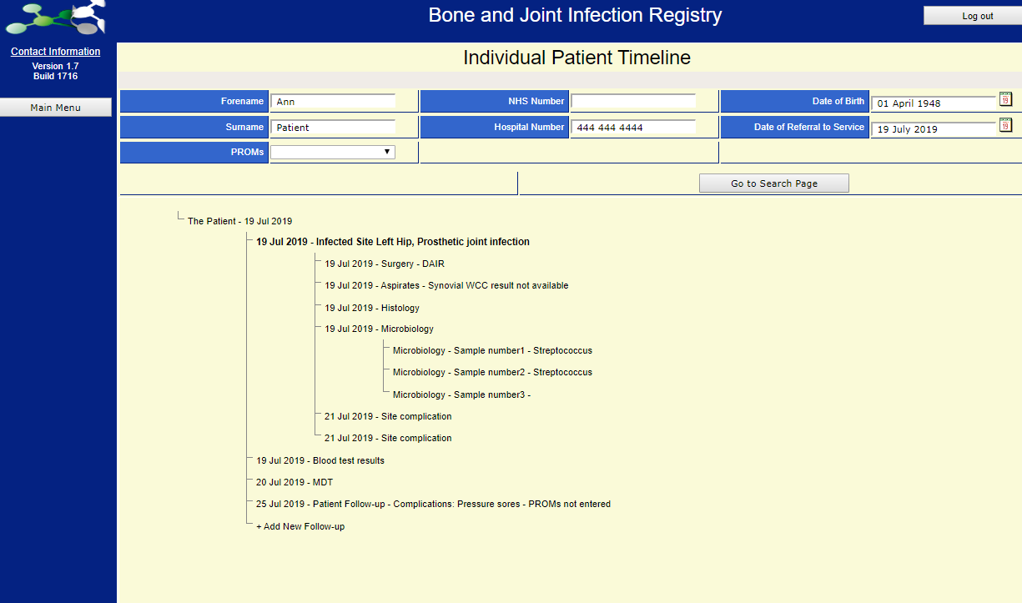

PROMs can be entered by clicking “Next Page” when entering systemic complications
or by
viewing the patient’s timeline and “Add New Follow Up”
PROMs – Page 1 of 2

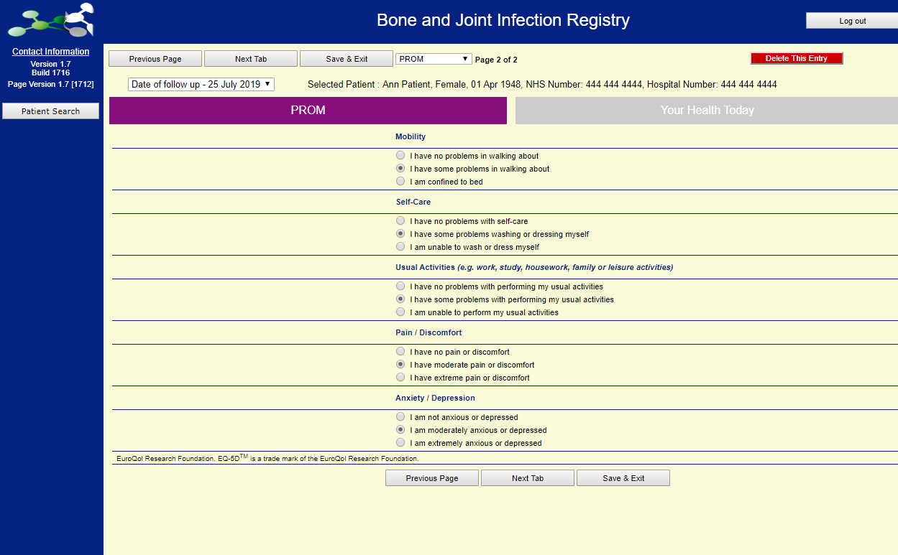
Click
Next Tab

Not

Save & Exit….
PROMS data collection forms will be sent out centrally by the BAJIR Team.
Data will be returned to the BAJIR Team and input centrally. This data collection will start at the six month review period.

Please ensure that the baselines PROMS information is input into the Registry

PROMs – Page 2 of 2

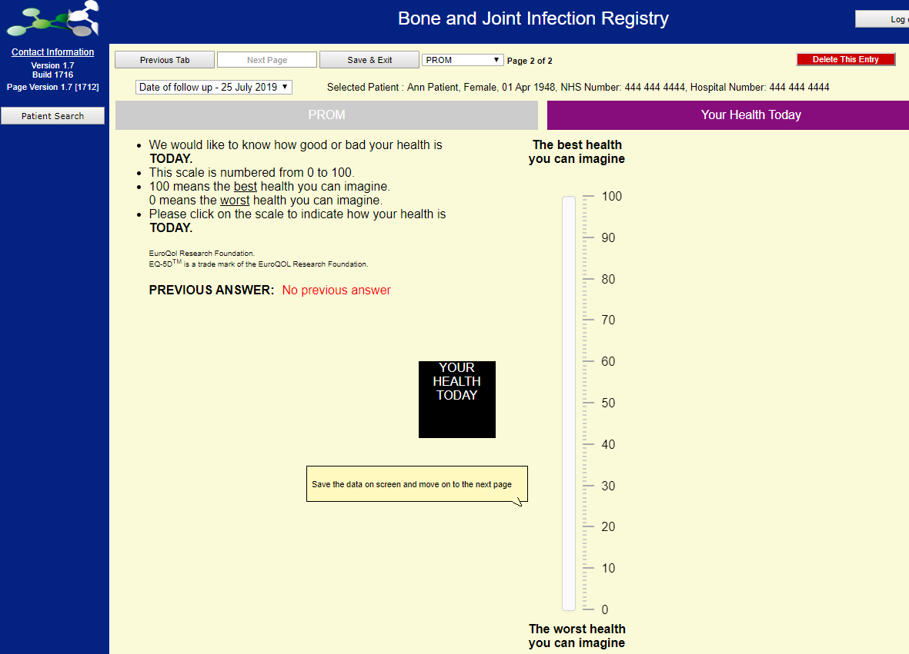
Click on

Save & Exit
My Patients

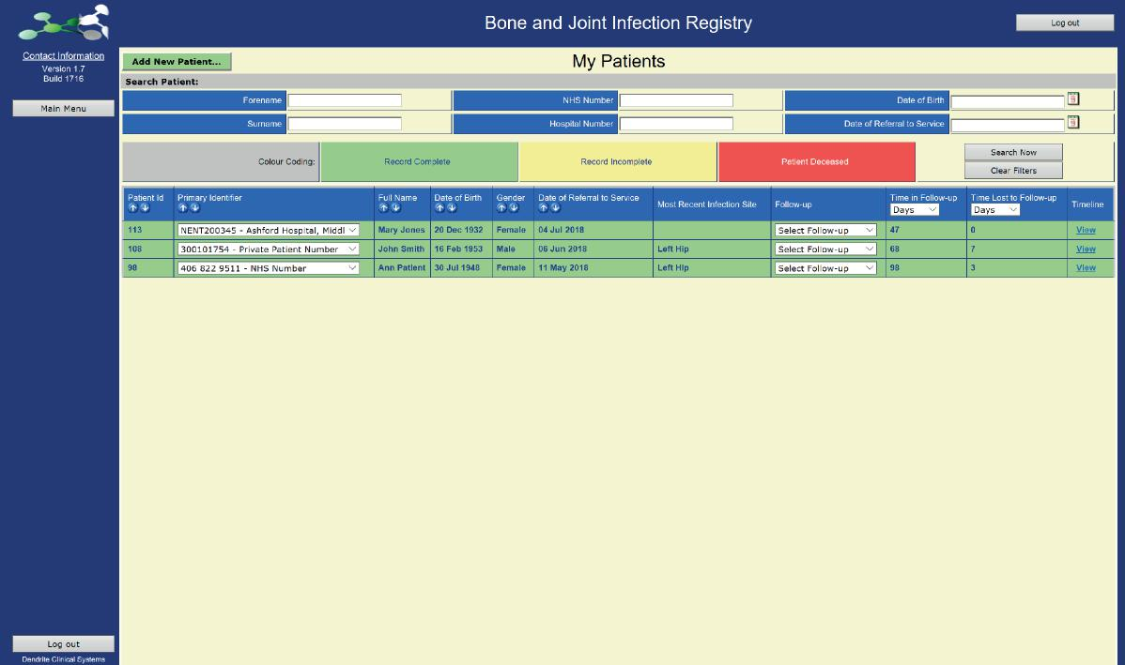
Once all of the required information is entered into the system, the patient record will turn green, to signify that all information has now been entered.

Don’t worry about having incomplete records in the registry, the registry can be updated as more case-level information becomes available.

As more records are added, it is possible to search for specific patients rather than having to scroll through the list of entries

Timeline

Here we have a timeline based on all of the information added to the registry regarding this particular patient.

Each line item is a hyperlink and will return to the registry screen where the information was initially entered.

There is also an option to update the patient record by clicking on the ‘Add New Follow Up’ text. At this point the date of the new follow-up episode is requested and all relevant information can then be added to the record

For additional support

For queries regarding the registry, including data entry, please contact:

Bone and Joint Infection Registry
Email: nhc-tr.bajir@nhs.net

If you are having any technical problems with BAJIR, please contact:

The Dendrite Team Telephone: 01491 411 288
Email: national-support@e-dendrite.com

If you would like to discuss accessing your data, please contact:

The Lead Consultant responsible for BAJIR within your organisation in the first instance
Professor Mike Reed mike.reed@nhs.net

